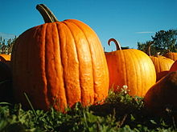
Pumpkin Competition Entry Form

Entrant Information
Name: Click or tap here to enter text.
Address: Click or tap here to enter text.
State: Choose an item. Post Code: Type here.
Email: Type email here Phone: Type number here

Entry Type
Major Prize: ☐ Heaviest Giant Pumpkin*

Payment: $10.00 per entry x Number of entries = $Type in Total Cost
Novelty Prize: ☐ Senior ☐ Junior (U15)
☐ Longest Gourd ☐ Largest Other Vegetable ☐ Ugliest Pumpkin
☐ Prettiest Pumpkin ☐ Best Dressed Pumpkin ☐Mystery Weight
Describe your Novelty Entry here. Do not put any identifying marks on entry.

Payment: $5.00 per entry x Number of entries = $Type in Total Cost

Entry Number: (as given by official) Dated:

Signed:
(Entrant) (Official)
*Only one entry (heaviest) will be deemed valid for prize award

